HAPPY GLASS

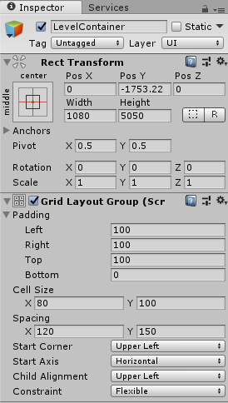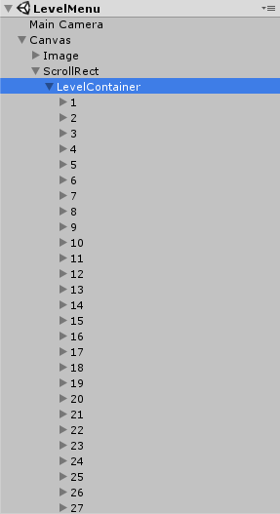

**How to Add Levels?**

You can add levels by two simple steps first thing you need to do is Open the LevelSelection Scene and duplicate the levels button as the parent gameobject has the grid script it will automatically adjust its position and also level no. now increase the Height of Parent Gameobject LevelContainer and decrease the Y pos of that object. Now you have to replicate the level scene and then just need to change the obstacle, glass, and tap positions according to your level design.

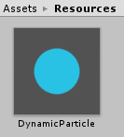

**How to Change Water Color?**

You can change water color by going into the Resource Folder there you will find a prefab naming DynamicParticle you have to just change the color of SpriteRenderer of that prefab.

**How to Configure AdMob ID?**

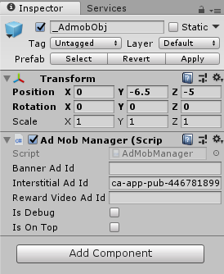

You can add your own Ad ID. All you have to do is open the MainMenu Scene and there will be a _AdMobObj GameObject in that you will find a script change the Ad IDS of that script according to your comfort.

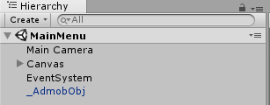

**How to Call Ad?**

If You want to call the Reward Video Ad for Hint you can open the ButtonManager.cs script in that there will be a function Hint() you can call ad from there FindObjectOfType<AdMobManager>().showRewardVideo;

Or if you want to call Interstitial Ad you write  
FindObjectOfType<AdMobManager>().showInterstitial;

**How to Import the Project below Unity 2018?**

As we were getting too many comments regarding this problem what you need to is create a new project in Unity of your required version and we have included a UnityPackage of the project you have to just import it in the new project you created and then you will find a rar file of project setting extract and replace your existing Project Settings and it will work fine will all the version.